

**WINTER SEMESTER 2020-21 SLOT: C1**

**CSE3013-ARTIFICIAL INTELLIGENCE**

**THEORY DIGITAL ASSESSMENT-II**

**Question 1:**

**On an airport all passengers are checked carefully. Let T with t ε {0, 1} be the random variable indicating whether somebody is a terrorist (t = 1) or not (t = 0) and A with a ε {0, 1} be the variable indicating arrest. A terrorist shall be arrested with probability P(A = 1|T = 1) = 0.98, a non-terrorist with probability P(A = 1|T = 0) = 0.001. One in hundred thousand passengers is a terrorist, P(T = 1) = 0.00001. What is the probability that an arrested person actually is a terrorist?**

**Question 2:**

**In an oral exam you have to solve exactly one problem, which might be one of three types, A, B, or C, which will come up with probabilities 30%, 20% and 50% respectively. During your preparation you have solved 9 of 10 problems of type A 2 of 10 problems of type B and 6 of 10 problems of type C.**

**a) What is the probability that you will solve the problem of the exam?**

**b) Given you have solved the problem, what is the probability that it was of type A?**

**Solution 1)**

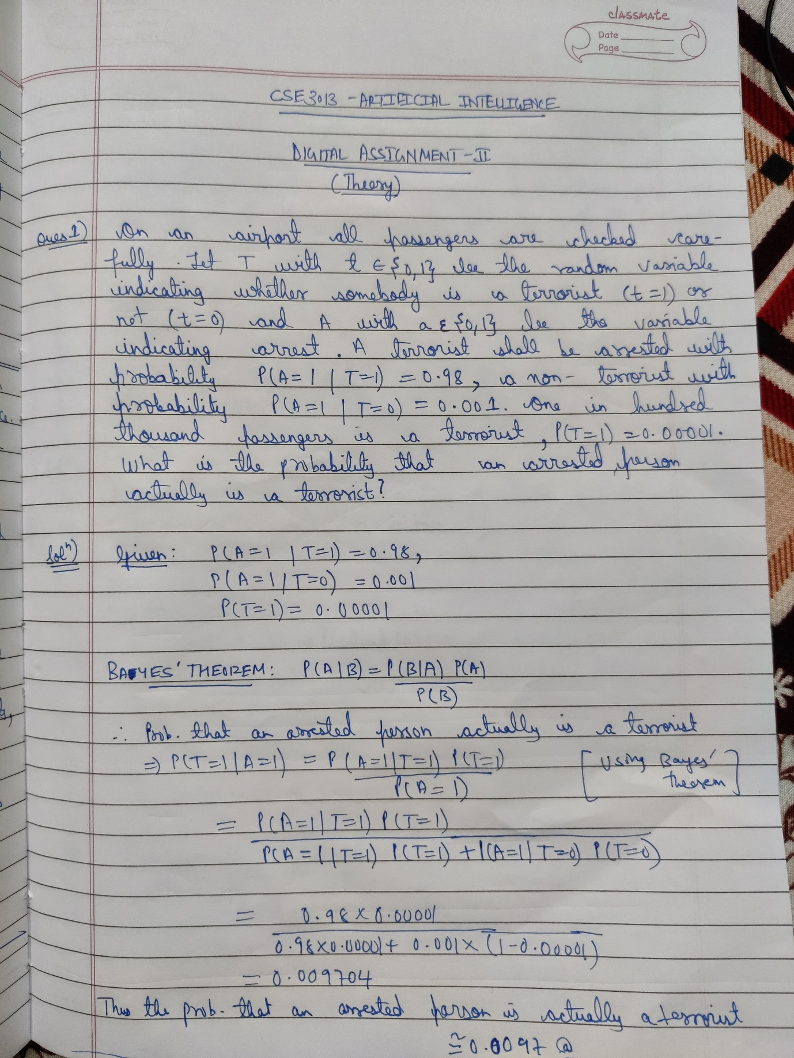

**Solution 2)**

